**CS1571  
Fall 2019  
11/06 Homework**

In the lecture on Wednesday, we are going to cover Chapter 14, with an emphasis on sections 14.1, 14.2, and 14.4. On Monday, we are going to move to Utility Theory and Markov Decision Processes, which span Chapter 16 and 17. For this week’s homework, I want you to focus on 16.1 and 16.2.

Answer the following questions:

1. (3 pts) Draw a Bayesian network based on the following scenario. You only need to represent nodes and directed edges between the nodes (probability tables are not necessary). Marcella is likely to be on time for her morning class if she did not oversleep, if she does not eat breakfast, and if there was not a lot of traffic on her drive in. Marcella is likely to eat breakfast if she is hungry. She is likely not to oversleep if she went to bed early the night before.
2. (3 pts) Given the following network (discussed in the reading), what is the probability that an earthquake has occurred, a burglary has not occurred, the alarm has sounded, Mary calls, but John does not call.

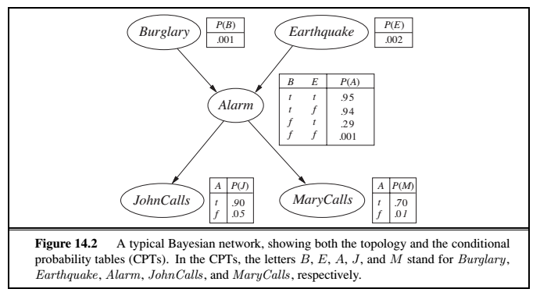

P(Alarm | !B & E) = .29

P(!JohnCalls) = .05

P(MaryCalls) = .70

1. (4 pts) The following is the formula representing Monotonicity, described on p. 613 of the textbook.

( *A*  *B* )  ( *p*  *q*  [ *p*, *A*; (1  *p*), *B* ]  [*q,* *A*; (1  *q*), *B* ])

1. In this formula, what do the following represent:
2. A

A possible outcome

1. q

One of the two lottery probabilities for A

1. 

the agent preferring one of the outcomes over another

1. [p,A; 1-p,B]

Determining the probability of one of the lotteries for A